Quarter 2
Journal #1
Draw a Venn diagram comparing prokaryotic and eukaryotic cells. There must be at least 3 items in each section.
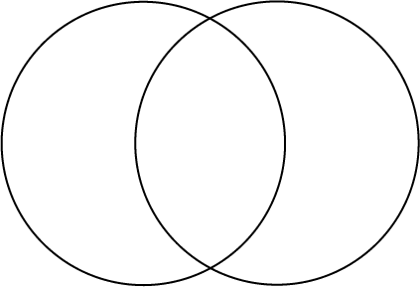
Eukaryotic
Prokaryotic
Both
1
2
3
1
2
3
1
2
3

Journal #2
5 sentence paragraph: comparing a cell to a city, a school or a business.
The cell is like a______________. First, the nucleus is like _____________________________ since it controls what the cell makes and does. Second, the mitochondria would be like the __________________________ because it has the job of ___________________________________. Third, vacuoles are a lot like ______________________ because they ____________________________________________ for the cell. Other structures of the cell could be compared as well because the cell carries on many activities like the ________________ does.

Journal #3
Diagram Joseph Priestley’s experiment and write a paragraph explaining his set up and conclusions.

Journal #4 Word Pairs
Choose 4 of the 5 word pairs below and make a sentence that relates to photosynthesis.
- Autotroph----producer
- Photosynthesis---sunlight
- Chlorophyll---green
- Glucose---fuel
- Pigments---solar energy

Journal #5 Thought bubble
Write 3 sentences bacteria might say to a eukaryotic cell doing cell division.

Journal #6 Sequencing
- Write the equation for photosynthesis
- Write the equation for respiration
- Write the stages of mitosis in order

Journal #7 Article on the discovery of DNA

Read the article and answer the following questions.

1. Why do you think it was it right/wrong of Watson to use Franklin’s picture without her knowledge to build their DNA model?

2. How might the discovery of DNA have been different if women had been considered equal to men in the laboratory?

3. What are your feelings about the behavior of the five scientists involved in the discovery of DNA?

Journal #8 Careers
Turn to page 322 in your book. Select one of the careers. Write a paragraph giving two reason why that career is important and two subjects you would need to study to pursue that career.

Journal #9 Genetic Coat of Arms
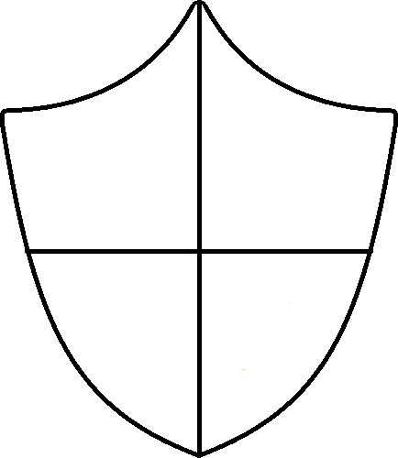
Create a coat of arms with 4 traits that your family is known for.

Journal #10 Blood Types
Turn to page 320 in your book. Answer the 4 questions in the Analyzing Data box. You must use complete sentences.

