Quarter 1
Journal # 1 Snow globe: What is science? (minimum of 4 sentences)
When you travel to a new city you will often see snow globes in souvenir shops. A snow globe in New York City would likely have the Empire State Building and the Statue of Liberty in it. In a snow globe from Los Angeles you would probably see the ocean, Disneyland, and Universal Studios. A snow globe bought in Utah as a souvenir might have the arches, Temple Square, the capital building and ski runs which we are famous for.
Think about what we have talked about so far regarding Science. If you walked into a Science store and saw snow globes for sale, what would be inside?

Journal #2 Tools: sorting diagram
Look at the notes we took on tools. Sort all the tools into categories below. Tools is in the center. One idea of how to sort them is shown.
Scissors

Tools for measuring
Tools for
Tools for

Tools for dissecting
Tools

Journal #3
Persuasive Paragraph
Write a letter to President Obama and persuade him that the country should switch to all metric measurements.
Your paragraph should include:
- Thesis statement (this is your topic sentence)
- Reason 1
- Reason 2
- Reason 3
- Conclusion (restate the topic or argument)

Journal #4
Alphabet: Desert vocabulary.
Watch the movie on deserts. On your paper, write the alphabet, A to Z. Next to each letter place a word that begins with that letter about the desert.
Example: D Dry

Journal #5 bull’s eye
Draw the diagram below with the levels of ecology. Using pages 64 and 65 in your book, write at least two words in each circle that describe that level.
biome
species
population
ecosystem
community

Journal #6 Ad
You have been hired by the Salt Lake Chamber of Commerce to make a commercial. Your ad will be about the Great Salt Lake and should convince others to come here to see it. Begin by describing the scene…..what will the commercial show about the lake? Then write the voice over….what will someone say in the commercial? You should have at least 2 descriptions or activities of things that people can do at the lake.

Journal #7 writing a set of instructions
Use your periodic table to write a set of instructions to be used by a 4th grade student. You are explaining how to draw an atom of phosphorus.

Journal #8 writing a list
Read page 39 in your book. Complete the instructions in the WRITING box.

Journal #9 Enzymes
Explain the lock and key theory of enzyme action. See page 52-53.
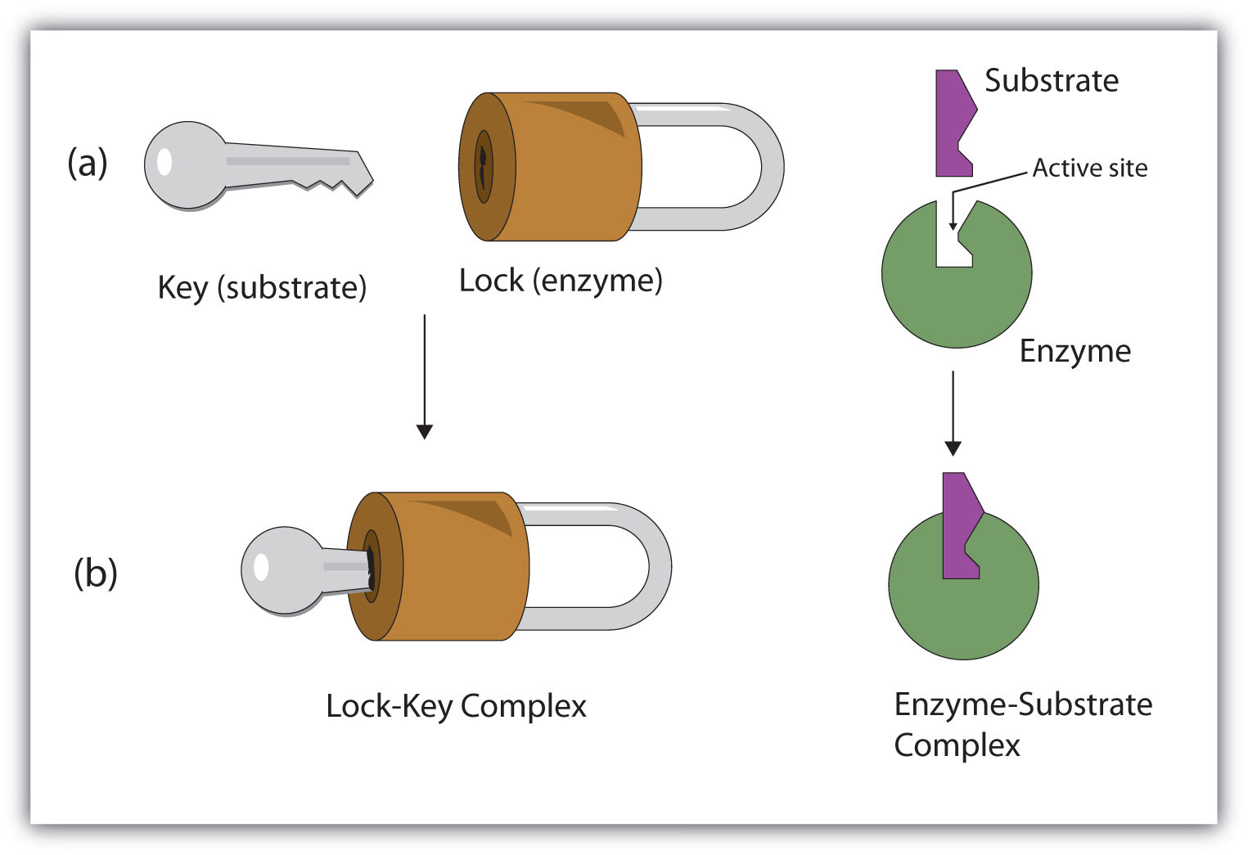

Journal #10

