Biology Pre and Post Test #4
Topics: Plants, Animals, Systems

- Which of the following represents the correct order of organization in living things, from simple to more complex?
- Lung, respiratory system, diaphragm, alveoli
- Skeletal system, bone cell, bone, marrow
- Heart cell, heart tissue, heart, circulatory system
- Brain, nerve cell, spinal cord, nervous system

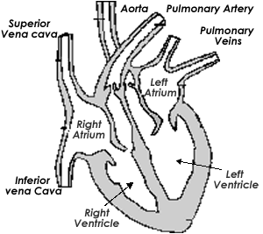
4
3
2

1

- On the diagram of the heart above, which vessels have oxygenated blood?
- Vessels 1 and 4
- Vessels 2 and 3
- Vessels 1 and 2
- Vessels 3 and 4

- Which of these vessels brings blood from the body to the heart?
- Inferior vena cava
- Pulmonary vein
- Pulmonary artery
- Aorta

- Which vessel takes oxygenated blood to the body?
- Vena cava
- Pulmonary vein
- Pulmonary artery
- Aorta

- The upper chambers of the heart are called
- Aorta
- Atrium
- Ventricle
- Vena cava

- Much of the water that plants take up from the soil is lost from the leaves. This process is called
  - Transpiration
  - Cohesion
  - Filtration
  - Capillarity

- To minimize water loss, leaves have a waxy coating. This is called the
  - Epidermis
  - Cuticle
  - Guard cell
  - Mesophyll

- Which of the following is a function of the roots in plants?
  - To store food
  - To anchor the plant
  - To take in water and minerals
  - All are correct

- Plants have tubes or vascular tissue to carry materials. Which of the following is correct about these tubes?
  - Phloem carries water up, xylem carries food down
  - Xylem carries water up, tracheids carry food down
  - Xylem carries water up, phloem carries food down
  - Phloem carries food up, xylem carries water down

- In order to survive, animals must be able to respond to their environment. Which system gives them this ability?
  - Respiratory
  - Digestive
  - Circulatory
  - Nervous

- Mammals have a muscle for breathing called the
  - Diaphragm
  - Meninges
  - Mesentery
  - Sarcomere

Matching: Match the animal group with their traits below.

- Breathe with gills, body covered with scales, 2 chambered heart a. mammals
- Live a “double life”, skin is moist, 3 chambered heart b. reptiles
- Dry, scaly skin, lay eggs with shells, well developed brain c. birds
- Body covered with hair, warm blooded, 4 chambered heart d. fish
e. amphibians

